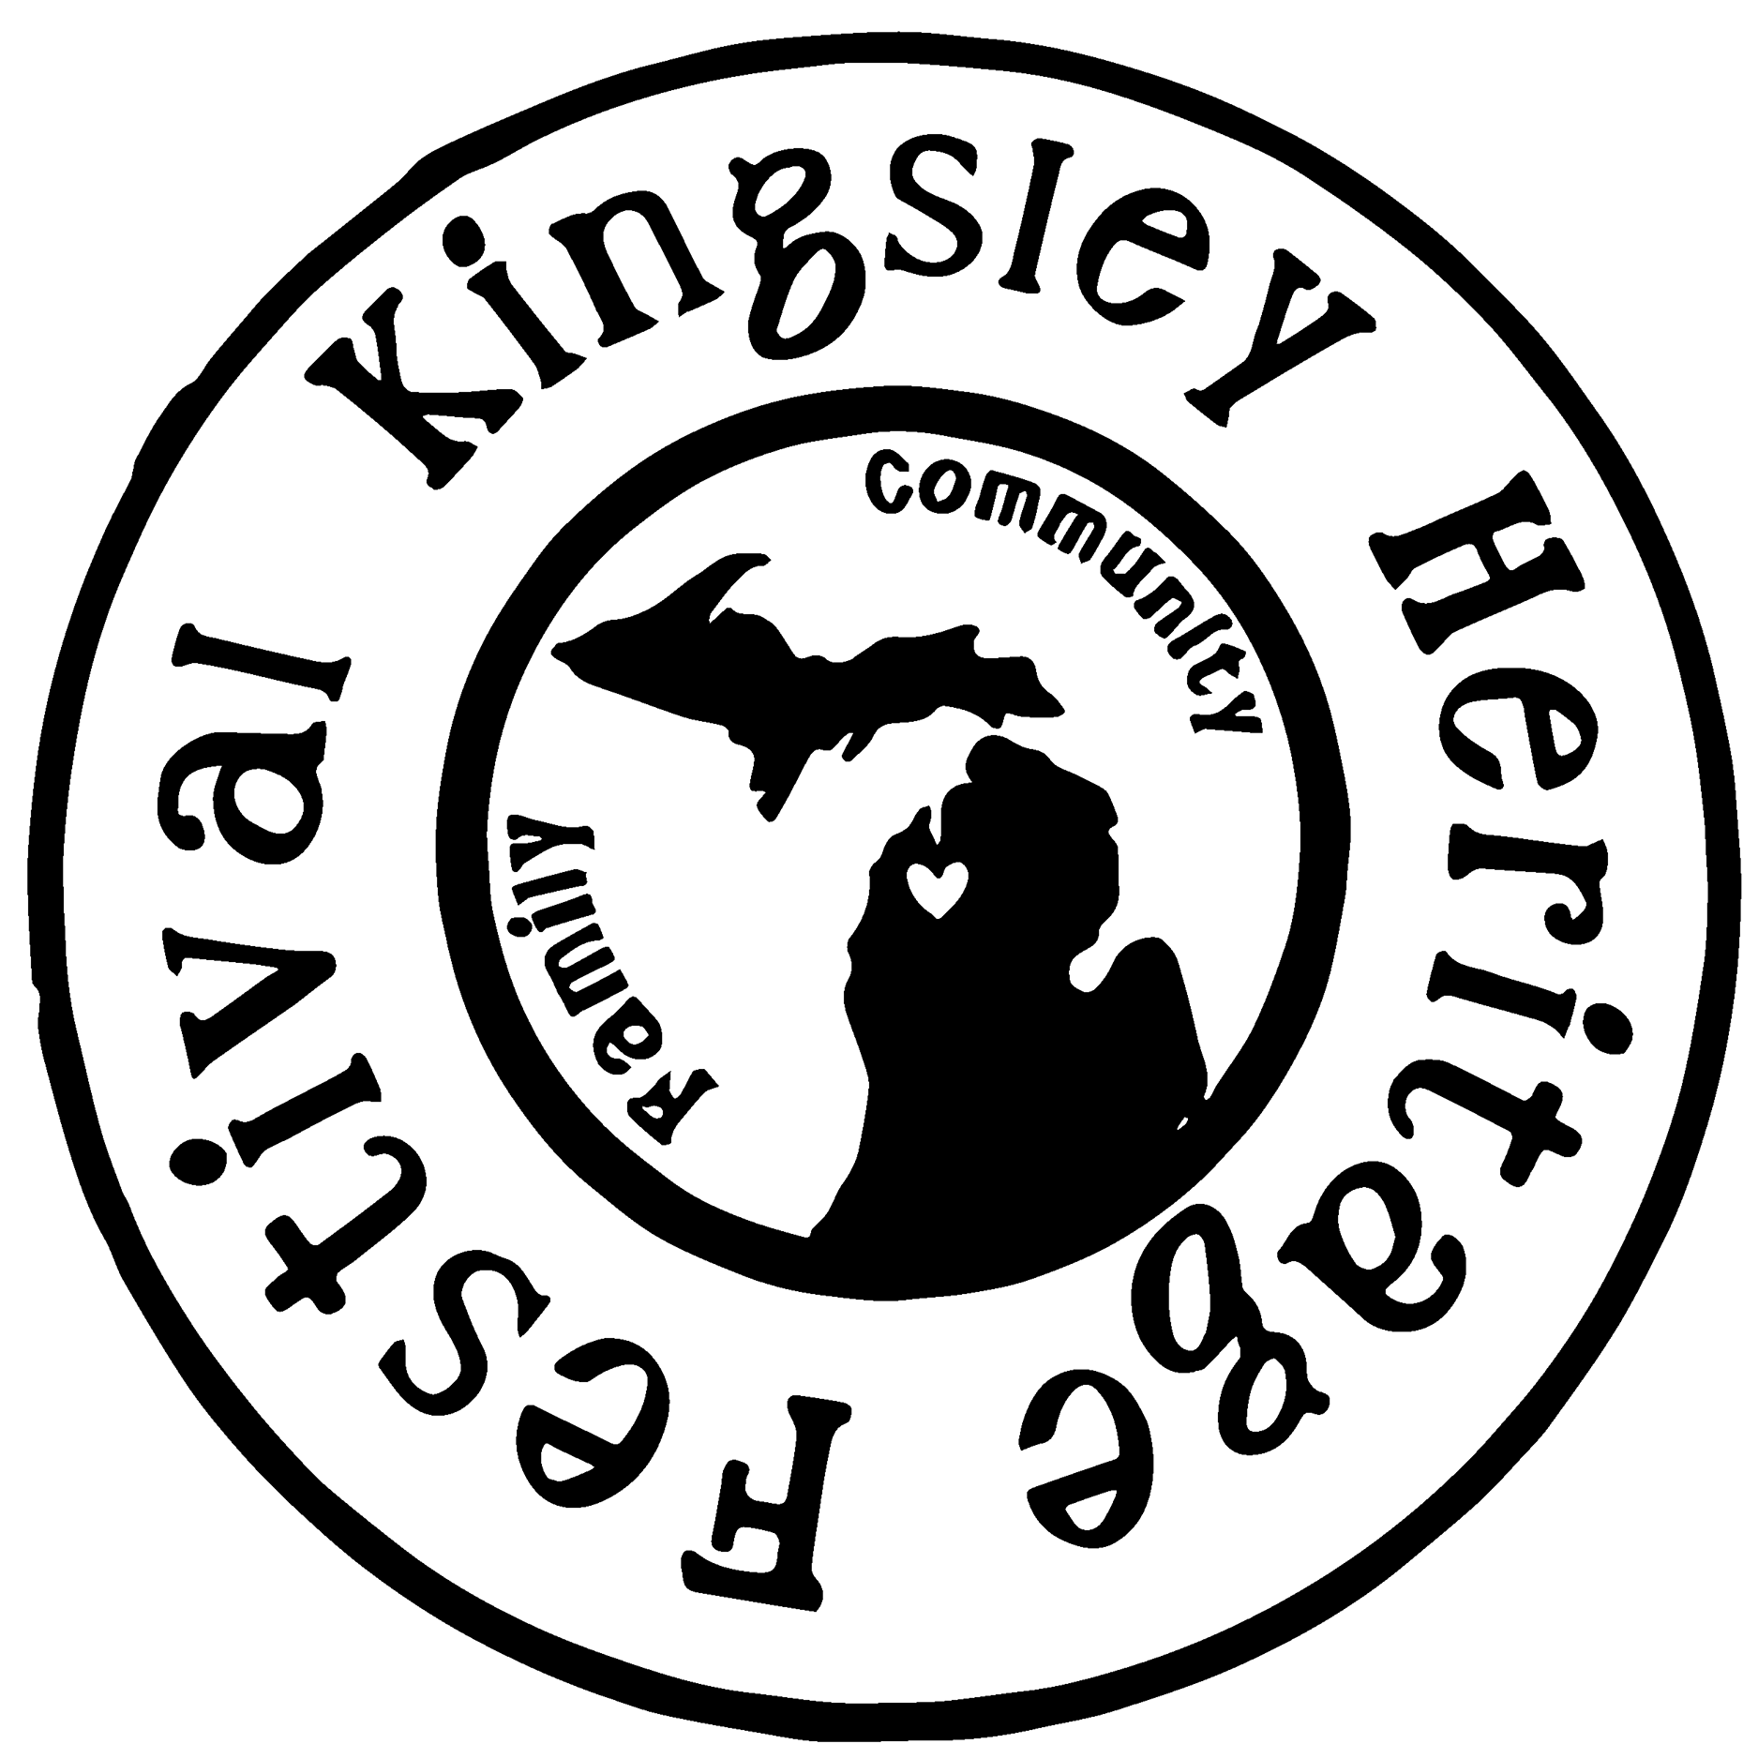
Friday, August 25, 2023
All Day- Large Lawn Games @ Civic Center South
12-pm- Concessions Open
4pm-9:30pm- Beer Tent @ Civic Center South Pavilion
6pm-9pm- Shelby Plamondon performs @ Beer Tent
Family Night @ Brownson Park
5:30pm- School Supplies Giveaway Grades 5-12
Pre Registration for The Rock After School Grades 6-12
Blessing of the Backpacks
6pm- Pizza Eating Contest by Papano’s Pizza
6:30pm- Movie in the Library w/ Popcorn by Kingsley Dance Company

Saturday, August 26, 2023
All Day- Large Yard Games @ Civic Center South
7am-8am- 5K/Fun Run Pre Registration @ Brownson Park
8am-9am- 5K/Fun Run by Kingsley Family Vision
8am- Mixed Doubles Scramble Round Robin Pickle Ball Tournament by Pickle U @ Civic Center South Ice Rink
8am- Softball Tournament @ Civic Center South Fields
10am- Blind Draw Switcholio Corn Hole Tournament @ Civic Center South Courts
11am- Kingsley Heritage Festival Parade through the Village
Carriage Rides by Two Fools Carriage @ Civic Center South Walking Path Following Parade
BB Gun Shoot by Kingsley Sportsman’s Club @ Civic Center South
11am-4pm- Craft/Vendor Market near Civic Center South Entrance
12pm- Partners Corn Hole Tournament @ Civic Center South Courts
12pm- Concessions Open
12pm-9:30pm- Beer Tent @ Civic Center South Pavilion
6pm-9pm- Knee Deep performs @ Beer Tent
Dusk- Movie in the Ball Field by Hangry’s @ Civic Center South

Sunday, August 27, 2023
10am-11:30am- Church in the Park by Kingsley United Methodist Church @ Brownson Park
11:30am- Blessing of the Backpacks @ Brownson Park

